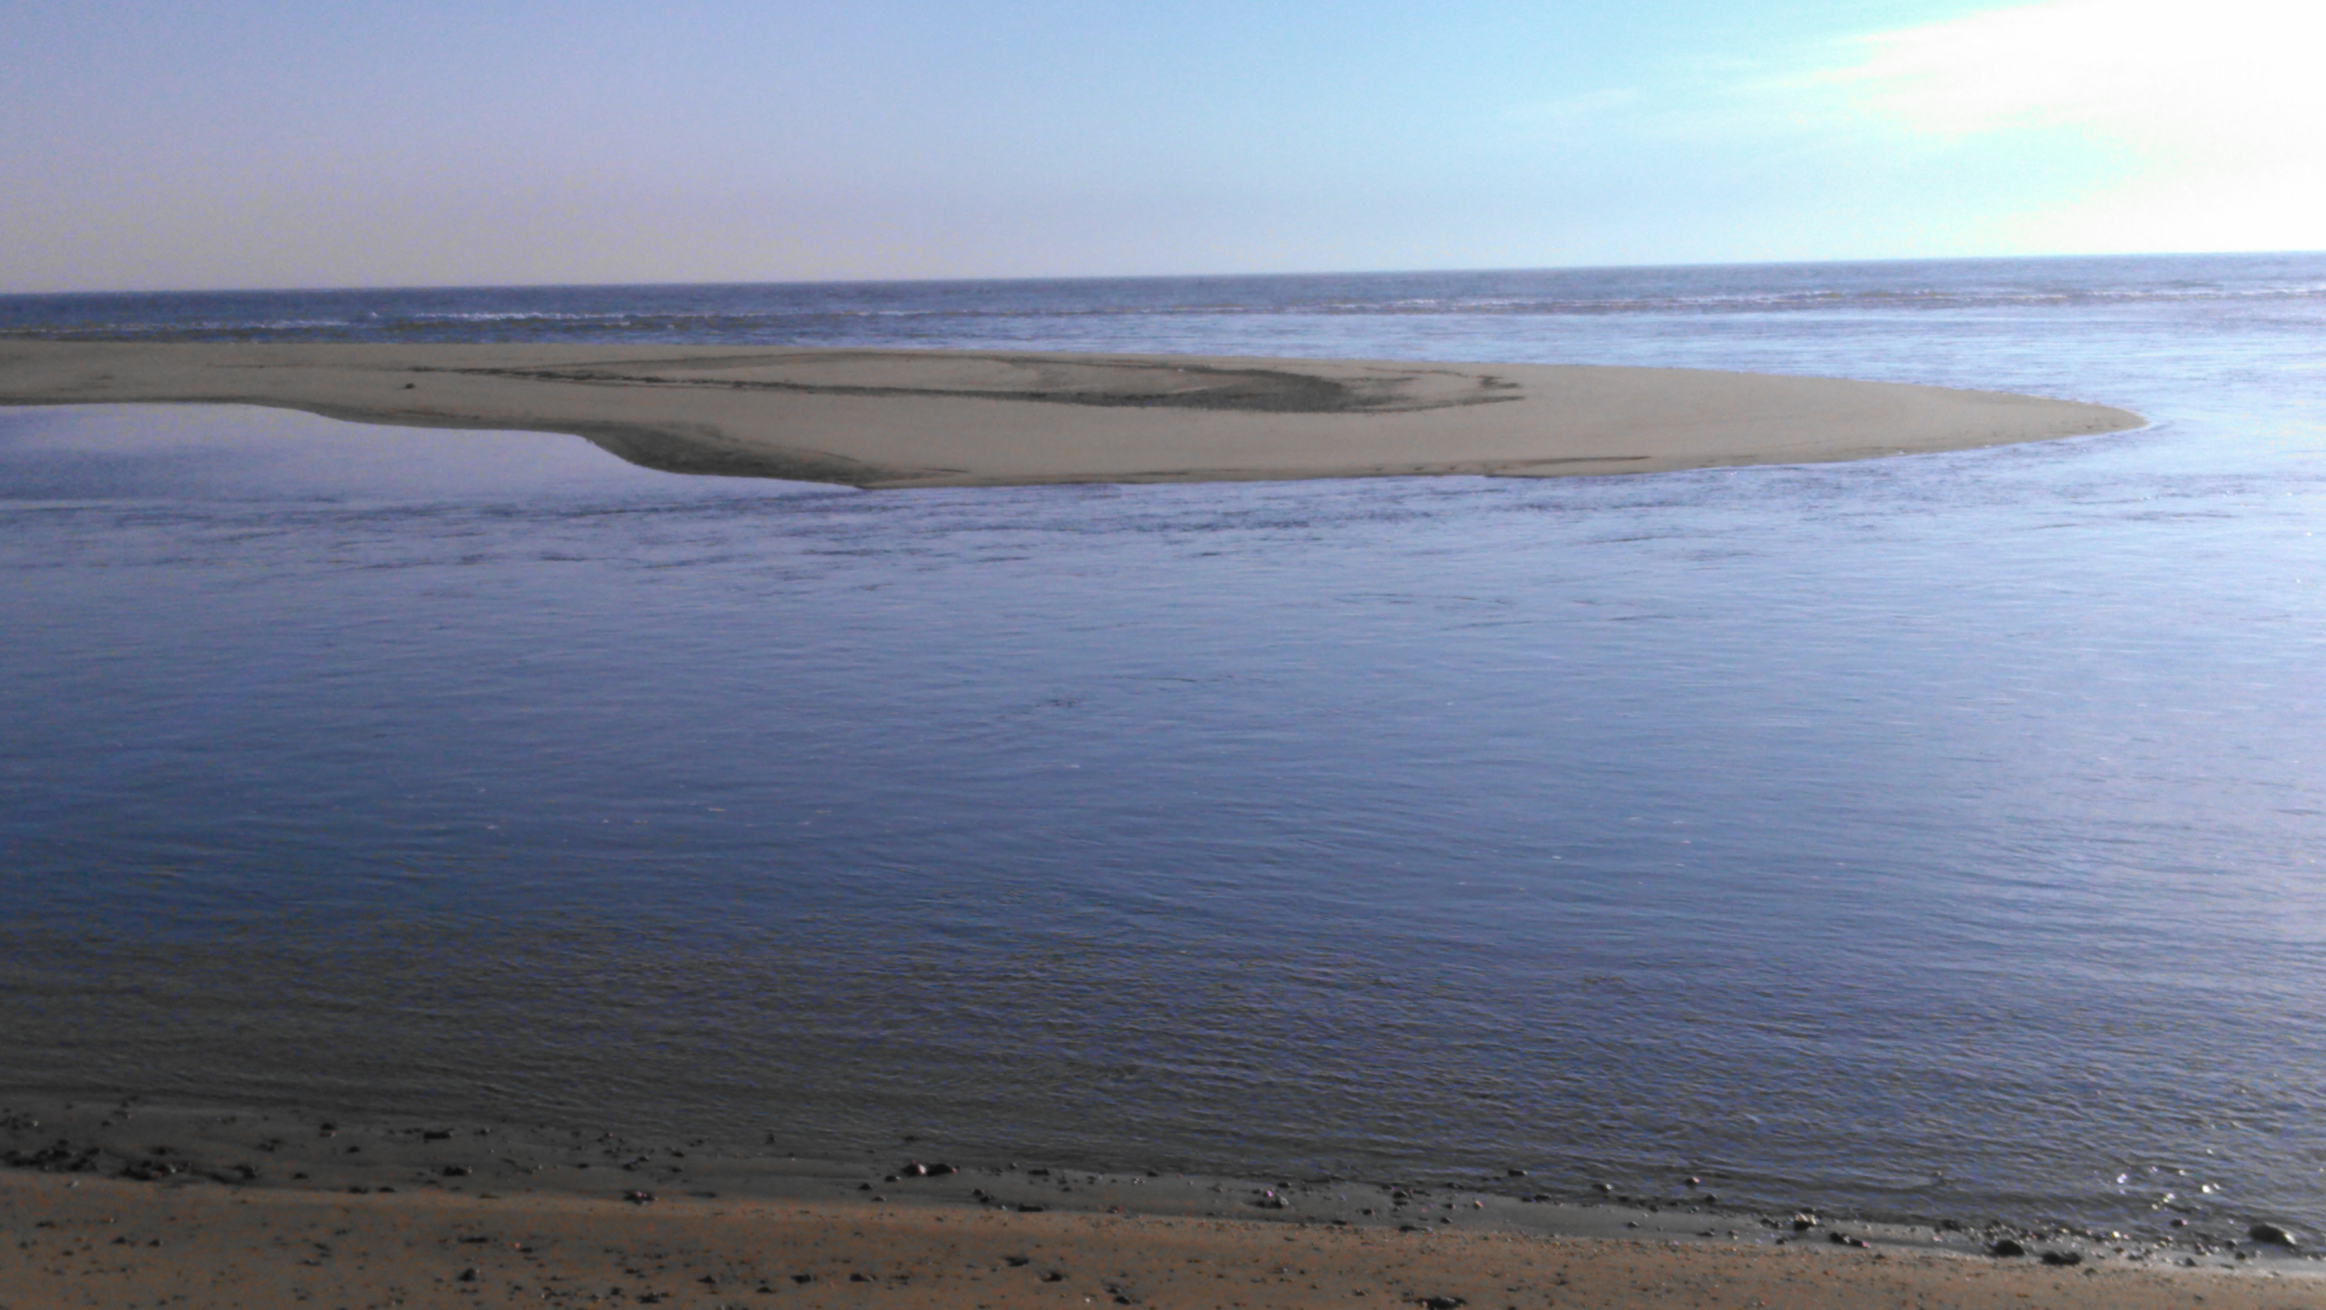
It's a view of the new sand bar that built and runs parallel to the Chappy shoreline. The point in the picture is less than a Hammer cast away.
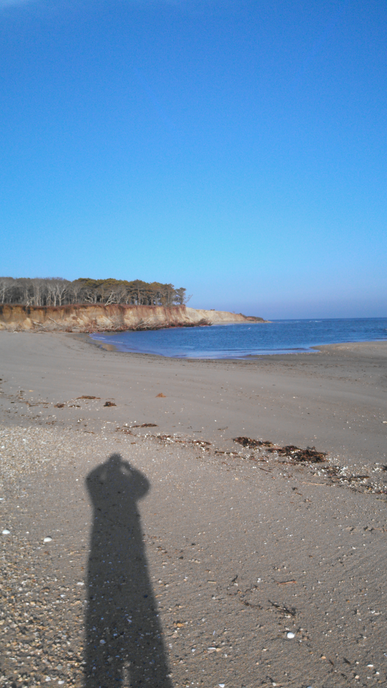
This is a shot of Wasque Point from the eastern end of the Chappy bathing beach. Wasque is about 200 yds. away.

